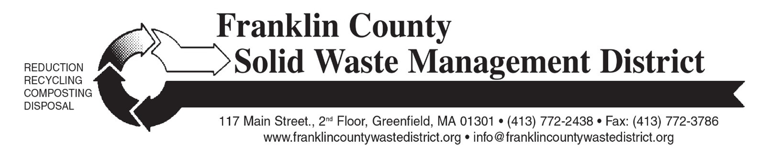

How to Compost and Recycle

Tuesday, October 6, 2026, 6 pm
Northfield Public Library Community Room
Dickinson Memorial Library
115 Main Street
Northfield, MA 01360

Free and open to all Franklin County residents
When you throw something “away” where does it go? How can households reduce trash and save money through composting and recycling? How do I compost at home? Do recyclables really get recycled? What is recyclable and compostable? Amy Donovan, Program Director at Franklin County Solid Waste Management District, will answer these questions and more. She will also share local resources for purchasing low cost home composting equipment, and tips for making composting easy and successful.

The Solid Waste District manages recycling, composting, and hazardous waste programs for 21 member towns, including 17 municipal transfer stations. Over the past 19 years, Amy Donovan has started 25 school compost programs and launched 15 municipal compost programs. She serves on the Advisory Board of the Springfield Materials Recycling Facility (MRF), where recyclables from Franklin County towns are sorted, baled and marketed for recycling.

For more information, contact amy@franklincountywastedistrict.org; (413) 772-2438. MA Relay for the hearing impaired: 711 or 1-800-439-2370 (TTY/TDD). The District is an equal opportunity provider.

